

Forecasting Monthly visitors for Yellowstone National Park

BAN 673 Time Series Analytics by Dr. Zinovy Radovilsky



Report by:

Pallavi Taneja | Sindhuja Neravetla | Payal Sahay | Komal Jaisawal | Rohini Krishnaraj



Table of Contents

Summary 2

Introduction 3

Background of the Park 3

Business Problem 3

Inside The Data 3

Exploratory Data Analysis 4

Times Series Data Plot 4

Times Series Components 4

Autocorrelation Chart 5

Yellowstone Visitors Seasonal Chart 5

Testing Predictability Of Data 6

Forecasting Methodology 7

Partitioning 7

Forecast Performance Baseline 7

Exponential Smoothing 8

Regression-Based Models 10

Two-Level models 13

Autoregressive & Moving Average Models 15

ARIMA Models 16

Model Comparison 19

Conclusion 20

Limitations & Way Forward 21

Appendix 21

Bibliography 21

Forecast Tables 22

# Summary

Yellowstone National Park is one of the largest National Parks in America. Spread over 2 million acres, Yellowstone National Park is a major destination for tourists all across the country appealing to all members of the family. The park is very rich in wildlife and geology diversity and is visited by millions of visitors each year. Owing to its diversity and popularity, the Yellowstone National Park witnesses different levels of footfall all the year round. Our project focusses on forecasting the number of monthly visitors to this National Park.

Such national parks experience periods of peak and low visitors, like time to holidays to weather; throughout the day, week, month and year, many predictable factors influence the ebb and flow of visitors. Since this park has an entry fee and the number of visitors directly impact the revenue of the park, like any other business, the park is also concerned with maximizing its profits while keeping the costs low. Therefore, developing an understanding of expected number of visitors in a month will help the park management to optimize their resources, plan well and be prepared to give their visitors a great experience.

Forecasting is a necessary tool to reduce the uncertainty (risk) in decision making and it serves as a starting point of major decisions in finance, marketing, operations, purchasing, and other functions. Nothing happens until somebody forecasts something and better decisions come from better forecasts. In this, project we have implemented the concepts of Time Series Forecasting to forecast the number of visitors in Yellowstone National Park every month.

We started with understanding the patterns in the park visits for the historical or original dataset using Exploratory Data Analysis techniques like data plot, time-series components plot and autocorrelation plot. We then implemented data-drive forecasting techniques like Naïve Forecast, Exponential Smoothing and model-based forecasting techniques like Regression models, Auto Regressive and Moving Average models to find out the best model that incorporates the nature of our data well and provides us with the most accurate results.

We collected the dataset from Kaggle.com. While this data includes various columns detailing the temperature and weather conditions for each month, we considered only the Recreation Visits to develop our forecasting models. At the end, we compared the performance measures of the various models we developed to find the most accurate one. This report is a predictive analytical approach to forecast one of the most critical aspects of the functioning of Yellowstone National Park, its visitors. We used R studio to perform forecasting and present results in the form of charts and model summaries.

# Introduction

## Background of the Park

Yellowstone National Park is a nearly 3,500-sq.-mile wilderness recreation area atop a volcanic hot spot. Mostly in Wyoming, the park spreads into parts of Montana and Idaho too. Yellowstone features dramatic canyons, alpine rivers, lush forests, hot springs and gushing geysers, including its most famous, Old Faithful. It's also home to hundreds of animal species, including bears, wolves, bison, elk and antelope. The park was established on March 1, 1872 and there have been approximately 183,430,851 visitors to the park till date.

## Business Problem

In addition to an incomparable combination of natural beauty, rugged wilderness, majestic peaks and abundant wildlife, as well as the world’s largest concentration of geysers and thermal features, the Yellowstone National Park is famous for its guided tours and attractions like dayhikes and backcountry explorations. The number of park visitors averages around 250,000 to 300,000 per month.

Our objective is to develop a forecasting model, that can accurately determine the number of visitors per month in the park. We are aiming at building a time-series forecasting model that incorporates the nature of our data well and predicts the highly accurate number of monthly visitors for the future periods.

## Inside The Data

Our dataset for time-series forecasting focuses on the recreation visits in Yellowstone National Park. It is a monthly dataset starting from January 1986 and ending at December 2016. There are 372 rows corresponding to 31 years’ monthly data and 20 columns.

The columns include number of recreation visits and some factors that may influence people’s visits to Yellowstone over months and years, such as weather and climate including temperature, precipitation and snowfall, travel costs via air and fuel costs for land travel, other macroeconomic factors like consumer price index, consumer sentiment index, and unemployment rate.

As our goal is to forecast the number of visitors, we have considered the Recreation Visits only to build the forecasting models.

# Exploratory Data Analysis

## Times Series Data Plot

We started our data analysis with plotting the time series data using the plot() function in R to get a sense of how the data for monthly visitors in the Yellowstone National Park look like.

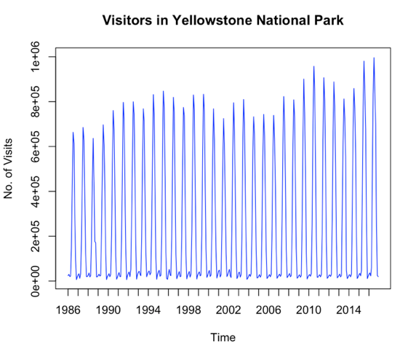

From the time series data plot, we can see that the pattern is repeating itself for every year. The peaks are growing towards the more recent periods suggesting a bit of upward trend in the data.

## Times Series Components

Every Time Series data comprises of systematic (level, trend and seasonality) and non-systematic components (noise). We used the stl() function to visualize these components for Yellowstone Time Series Data.

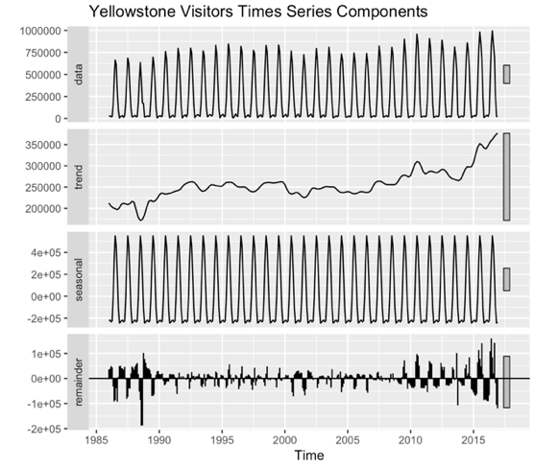

From the plot above, in the trend component we can see that there is global upward trend but locally it declines and rises like a sine wave. The seasonal component shows that there is cyclic behavior in the data. These last component remainder is basically a combination of level and noise.

## Autocorrelation Chart

Autocorrelation represents the correlation between a random variable (time series data) itself and the same variable lagged one or more periods. We used the acf() function to plot the autocorrelation chart, to evaluate if the values in the neighboring periods are correlated.

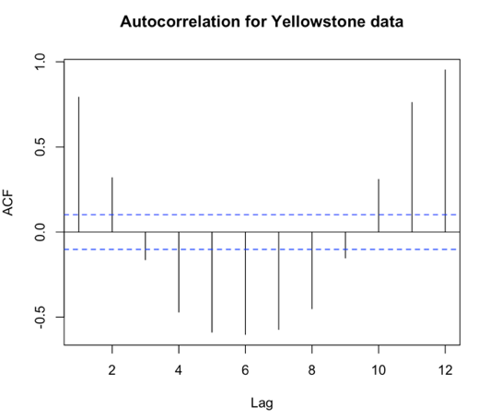

From the correlogram it can be observed that there is positive autocorrelation coefficient in Lag 1 as it is substantially higher than horizontal threshold. It however, does not stay positive in the corresponding lag periods which suggests that the data is more or less leveled. A positive autocorrelation at Lag 12, which is statistically significant (outside the horizontal threshold) suggests that there is monthly seasonality in the data.

## Yellowstone Visitors Seasonal Chart

The visualizations above indicated towards months seasonality in the data, therefore we plotted a seasonal chart for the data to see how visitors vary with the months.

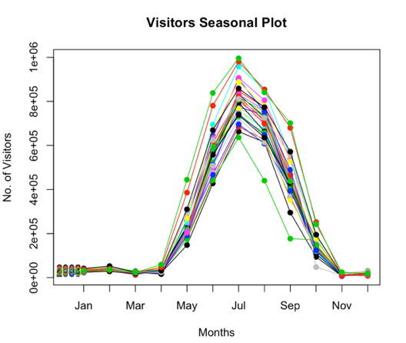

The chart above shows that year after year there is significantly low visitor footfall at the Yellowstone National Park in the Winter and Spring (from November to April). The park witnesses increasing number of visitors from May onwards, gaining a peak in the Summer time (June, July and August) and gradually decreasing in Fall (September and October). This is a very valuable piece of information for the Yellowstone National Park management and forecasting density of visitors in the respective periods is very key to the successful planning by the Park.

## Testing Predictability Of Data

Before we attempt to forecast a time series data, it is important for us to know if the data is even predictable and subsequently forecastable. We need to know that the data is not a random walk and if forecasting effort will be useful or not and should we even go beyond the Naïve forecast. In order to test the predictability of the Yellowstone data, we have used two approaches: 1) Fit an AR(1) model to test the hypothesis that the slope coefficient β1 = 1 and 2) Examine differenced series: Y2-Y1, Y3-Y2, … , YT -YT-1 which is the mathematical equivalent of approach 1.

**Approach 1:**

A partial output of the AR(1) model for visitors time series data is presented below. ARIMA(1, 0, 0) is an autoregressive (AR) model with order 1, no differencing, and no moving average model.

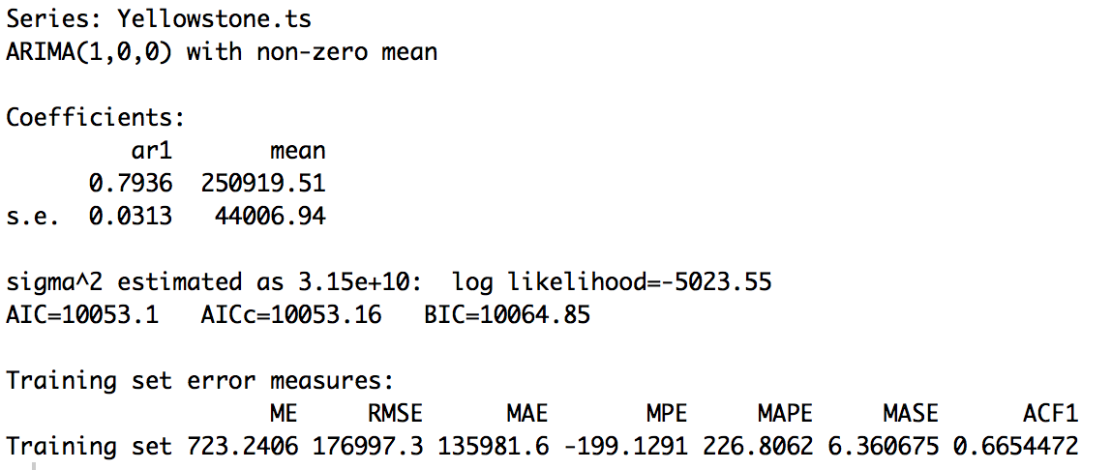

The *AR(1)* model equation is:

***Yt* = *250919* + *0.7936 Yt*-1**

The coefficient of the *ar1* (*Yt*-1) variable, *0.7936*, is well below 1. With the confidence of 95%, the upper value of this coefficient (the population value of this coefficient) will be *0.7936* + 2*0.0313= 0.8562, which is still below 1. Therefore, *Yellowstone.ts* time series is not a random walk and is predictable.

**Approach 2:**

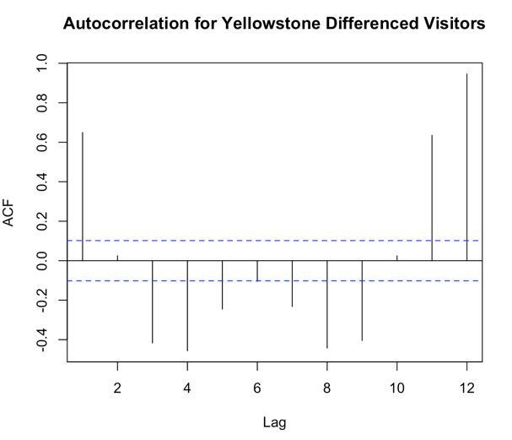

In the chart above, several autocorrelation coefficients of the first differenced data are statistically significant, in particular, in lag 12 (for monthly seasonality), lag 1,3,4,8,9 and 11. Therefore, using the first differencing approach, we can confirm that Yellowstone.ts is not a random walk and is predictable.

# Forecasting Methodology

## Partitioning

Partition Series is an important preliminary step before applying any forecasting method. It comes from the need to be able to test how well any selected model performs with the new data not included in the model development. Therefore, we created a data partition of 312 records for training period which includes data points from January 1936 to December 2011. The data for most recent 5 years i.e. from January 2012 to December 2016 was considered for validation period with a total of 60 records. We have built various forecasting models using the training data and measured its performance using the validation data.

## Forecast Performance Baseline

A baseline in forecast performance provides a point of comparison. It is a point of reference for all other modeling techniques on the problem. If a model achieves performance at or below the baseline, the technique should be improved or abandoned completely. The most common baseline method for timeseries forecasting is Naïve Model approach.

*NAÏVE & SEASONAL NAIVE FORECAST:*

It is the simplest form of model. In this approach forecast for any period equals the previous period’s actual value. Since, this model gives full weight to the last period original value it is not able to capture the features of data series.

For highly seasonal time series data like ours, Seasonal Naïve Forecast can be a good baseline. Seasonal Naïve method is like the naive method but predicts the last observed value of the same season of the year.

Before diving into sophisticated algorithms, we evaluated the performance of both Naïve and Seasonal Naïve forecast to set a baseline and the results are as follows:

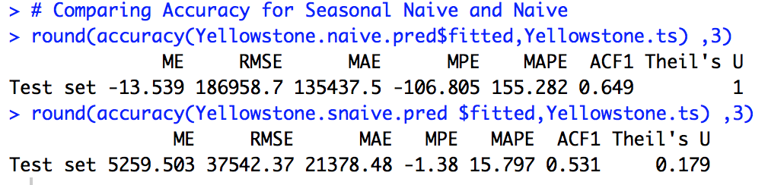

We can see that the MAPE and RMSE values for Seasonal Naïve are substantially better than the Naïve forecast. Therefore, we can say that it will be worthwhile to evaluate the performance of more sophisticated forecasting methods.

## Exponential Smoothing

Exponential Smoothing is a data-driven approach to perform time series forecasting. Exponential smoothing estimates time series components (level, trend, and seasonality) directly from the data without a predetermined structure. They smooth out the noise in a time series data to uncover the data patterns. We have performed advanced smoothing through Holt-Winter’s model that incorporates both trend and seasonality in the data.

*HW MODEL ON TRAINING DATASET:*

Holt-Winter’s model for the training dataset along with the automated selection of the model options and optimal smoothing parameters:

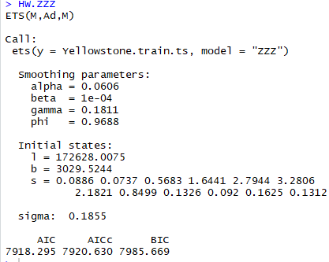

This Holt-Winter’s model has the (M, A, M) options, i.e., multiplicative error, Additive trend, and multiplicative seasonality. The optimal value for exponential smoothing constant (alpha) is 0.0606, The optimal smoothing constant for trend estimate (beta) is 0.0001, and smoothing constant for seasonality estimate (gamma) is 0.1811. The alpha value of this model indicates that that the model’s level component tends to be more global, while trend is globally adjusted as beta is close to zero. The higher gamma value indicates that more recent seasonal component is weighed in a forecast.

The Forecast plot for Holt-Winter’s model on the training and validation dataset is given below and the table is in appendix.

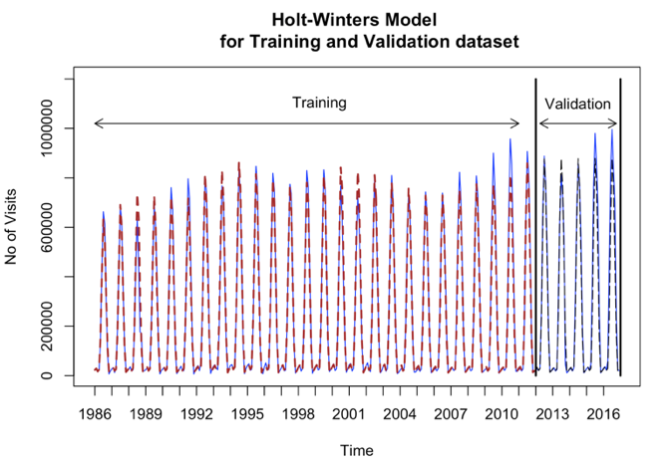

*HW MODEL ON HISTORICAL DATASET:*

In order to forecast future values of the series using the Holt-Winter’s model, the training and validation periods were recombined into the entire (historical) time series dataset.

The summary for the Holt-Winter’s model for the entire dataset along with the automated selection of the model options and optimal smoothing parameters is given below: 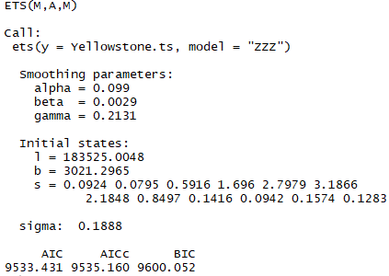

This Holt-Winter’s model has the (M, A, M) options, i.e., multiplicative error, Additive trend, and multiplicative seasonality. The optimal value for exponential smoothing constant (alpha) is 0.099,optimal smoothing constant for trend estimate (beta) is 0.0029, and smoothing constant for seasonality estimate (gamma) is 0.2131. The alpha value of this model indicates that that the model’s level component tends to be more global, while trend is globally adjusted as beta value is close to zero. Higher gamma value indicates that more recent seasonal component is weighed in a forecast.

The Forecast plot for 12 periods into the future using the Holt-Winter’s model on the entire dataset is given below and the table is in appendix.

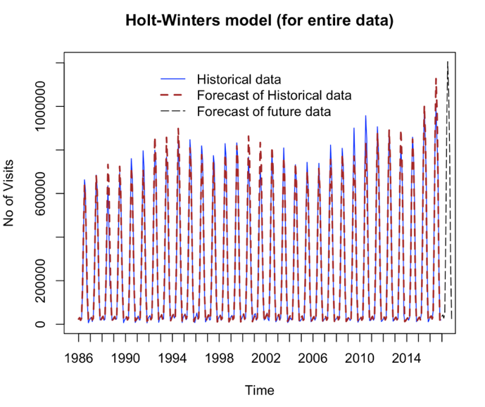

## Regression-Based Models

Regression-based models fall under the model-based approach of Time Series forecasting and are useful for Data visualization and Multi-period forecasting.

Based on the Acf plot, data plots and visualized time series components we are certain that there is seasonality in the data and hence we chose regression models with seasonality, i.e., Quadratic Trend + Seasonality and Regression Model with Seasonality as the most appropriate models for forecasting our data.

*REGRESSION MODEL WITH SEASONALITY FOR TRAINING DATASET:*

To de-seasonalize the training data set, we developed a regression model with seasonality and the summary is as follows:

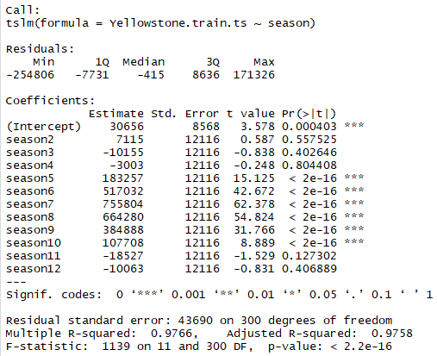

This model contains 12 Predictors including Intercept and 11 seasonal dummy variables for February (Season 2) through December (Season 4).

The Regression equation is

***Yt = 30656 + 7155D2 - 10155D3 -3003D4 + 183257D5 +… - 10063 D12***

This model has a very high R squared of 0.9766 and Adjusted R Squared of 0.9758. The F- statistics p-value is lower than 0.01 which means overall the model is statistically significant. However, the regression coefficient for Season 2, 3, 4, 11 and 12 is not statistically significant (p-value is greater than 0.01). We used the forecast() function to predict the values in the validation period, the forecast plot is as follows and the table is in the appendix.

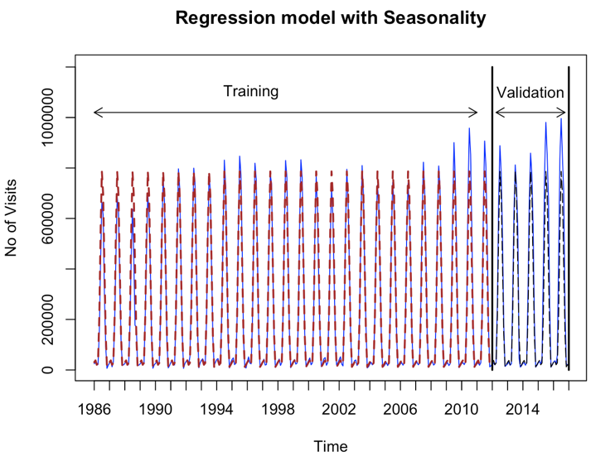

*REGRESSION MODEL WITH QUADRATIC TREND AND SEASONALITY FOR TRAINING DATASET:*

To de-trend and de-seasonalize the training data set, we developed a regression model with quadratic trend and seasonality and the summary is as follows:

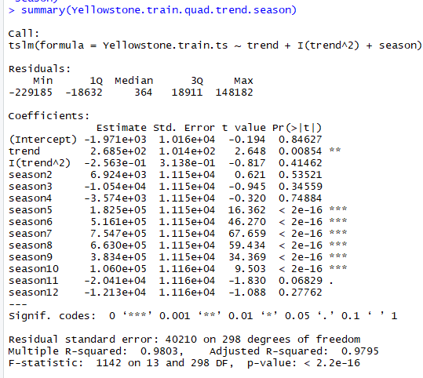

The model contains 13 predictors including 11 seasonal dummy variables from Season 2 (February) through Season12 (December). The model equation is:

***Yt = (-1.971e+03) + (2.685e+02t) – (2.563e-01t2) + (6.924e+03D2) – (1.054e+04D3) + … – (1.213e+04D12)***

This model too has a very high R squared of 0.9803 and Adjusted R Squared of 0.9795. The F- statistics p-value is lower than 0.01 which means overall the model is statistically significant. However, the intercept and regression coefficients for Season 2, 3, 4, 11 and 12 are not statistically significant (p-value is greater than 0.01). We used the forecast() function to predict the values in the validation period, the forecast plot is as follows and the table is in the appendix.

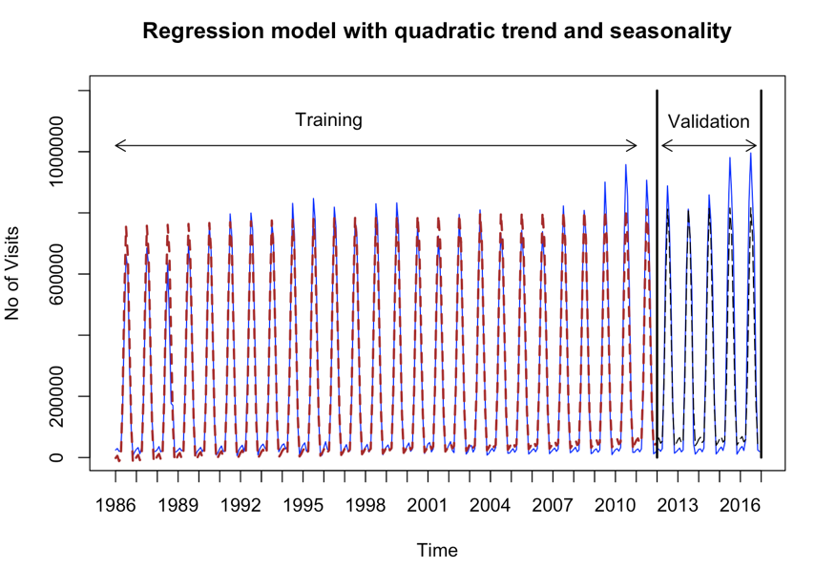

*ACCURACY COMPARISON FOR BOTH REGRESSION MODELS:*

We used accuracy() function to evaluate the better model from the two regression models we built above.

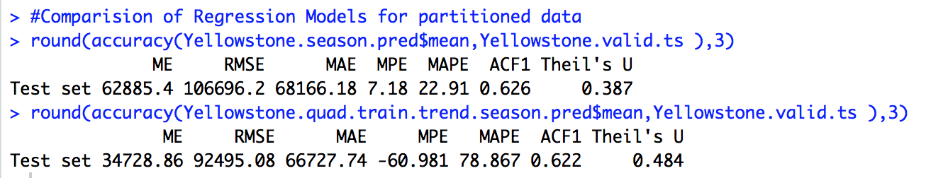

From observing the above accuracy measures, Regression model with seasonality have substantially better MAPE (22.91) that Regression Model with Quadratic Trend and Seasonality (78.867). The RMSE value for the regression model with quadratic trend and seasonality (92945.08) is better than regression model with seasonality (106696.2). Taking into consideration the superiority of MAPE, we conclude that Regression model with Seasonality is a more accurate model among these regression models.

*REGRESSION MODEL WITH SEASONALITY ON HISTORICAL DATA:*

Before attempting to forecast future values of the series, the training and validation periods were recombined into the entire (historical) time series dataset. The chosen model regression model with seasonality was then run on the entire historical dataset.

Here we are using regression model with seasonality on original data and the summary is as follows:

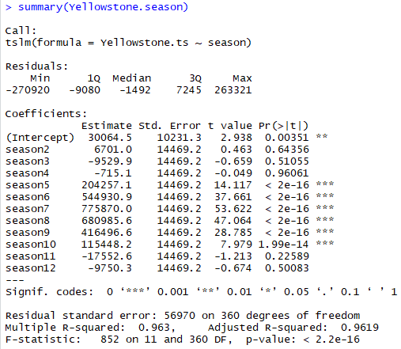

This model contains 12 predictors which includes 11 seasonal dummy variables from season 2 (February) through season 12 (December).The Regression equation for the above model is

**Yt = 30064.5+6701D2 – 9529.9D3 -715.1D4 + … - 9750D12**

Both R squared(0.963) and Adjusted R squared(0.9619) values are relatively high for this model and overall model also seems to be statistically significant as their F-statistic P-Value is less than 0.01. However, regression coefficients for season 2,3,4,11 and 12 is not statistically significant(P-value is greater than 0.01).

The forecast for 12 periods into the future was done using the forecast() function. The plot is as follows and the table is in the appendix.

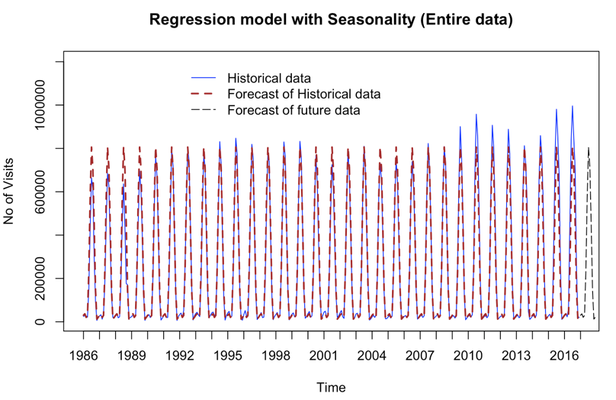

## Two-Level Models

To improve the predictive performance, we combine multiple forecasting methods where the first method uses original time series to predict future, and the second method uses forecast residuals from the first method to generate forecast for errors, and then combine two forecasts together.

Here we have used Regression Model with Seasonality to create the forecast for the training data and used Trailing Moving Average to forecast the residuals of this model. Below is the table for Two Level Model - Regression with Seasonality and Trailing MA for residuals and total forecast for the validation data.

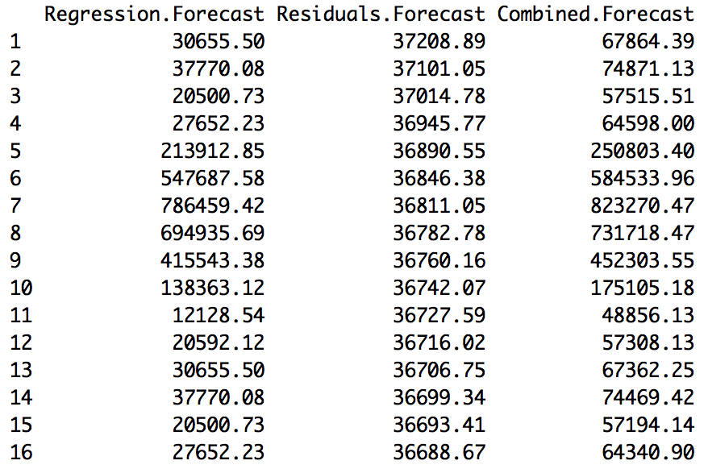

We recombined the partitioned data into one dataset and reapplied the two-level model built above. The table below contains forecasts of visitors for the year 2017 including regression forecast, trailing MA forecasts for residuals and the total forecasts that combines first two forecasts.

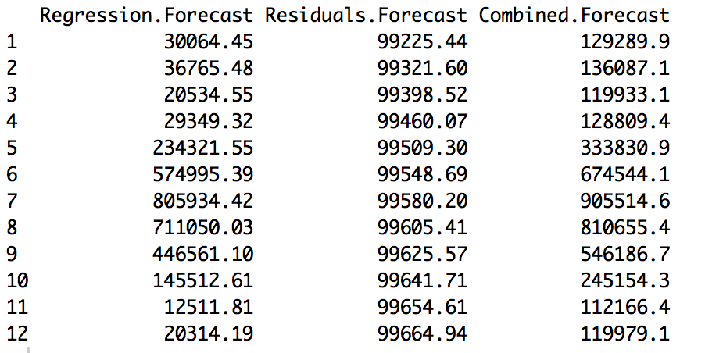

The forecast plot is as follows:

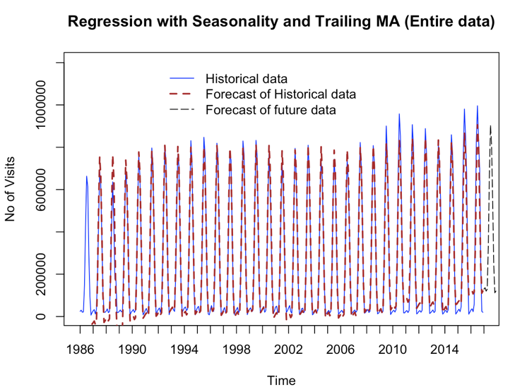

## Autoregressive & Moving Average Models

Autoregressive models are model-based approach of Time Series Forecasting and they model the existing relationship between successive datasets or autocorrelation directly in regression model, using past observations as predictors. They are similar to the linear regression models, except that the predictors are the past values of the series. We built multiple models to compare and find the most accurate one.

*AUTOREGRESSIVE (AR) MODEL OF ORDER 2 ON TRAINING DATA:*

We build an Autoregressive model of order 2 on the Training Data and below is the summary.



As can be seen from the above summary the β1 coefficient is 1.4587 , β2 coefficient is -0.8476 with the intercept is 246393.20. And, the Model equation is as follows:

***yt = 246393.20  + 1.4587 yt-1 - 0.8476 yt-2***

We then applied the forecast() function to make predictions for Validation period and the results are shown in the appendix.

*MOVING AVERAGE (MA) MODEL OF ORDER 2 ON TRAINING DATA:*

Moving Average model uses past forecast residuals (errors) of q autocorrelation lags in a regression-like model. We used Arima() function to fit MA(2) model with order = c(0,0,2) for Moving average and the results are as follows:



The model equation is as follows:

***yt* =  *244380.52* + *1.4350et-1* + *0.8722et-2***

We used forecast() function to make predictions for Training data with the above MA model in validation set and the results are in the appendix.

*AUTOREGRESSIVE MOVING AVERAGE (ARMA) MODEL OF ORDER 2 ON TRAINING DATA:*

We also used ARMA model that incorporates time series lags (‘Autoregressive’ part) and lags of forecast residuals (‘Moving Average’ part) to capture all forms of autocorrelation in the data. We used ARMA(2,2) model with order = c(2,0,2) in ARIMA function and the results are as follows.



The model equation is as follows:

***yt = 245452.40 + 1.2220 yt-1 - 0.6855 yt-2 + 0.7481et-1– 0.3455et-2***

We applied forecast() function to make predictions for validation period with ARMA model and the results are in the appendix.

## ARIMA Models

Autoregressive Integrated Moving Average (ARIMA) is a class of popular models in time series forecasting and is also referred to as Box-Jenkins methodology or Box-Jenkins approach.

ARIMA Models are capable of presenting any time series component – level (stationary), trend, and seasonality – or a combination of these components. These are model-based approach for forecasting and are flexible to forecast any time series. We built multiple versions of ARIMA Models to forecast the Yellowstone National Park’s times series data.

In order to incorporate trend and seasonality components we built Seasonal ARIMA Model. We used Arima() function to fit ARIMA(2,1,2)(1,1,2) model for trend and seasonality.

ARIMA (p, d, q) (P, D, Q)m model is used to forecast data with level, trend, and seasonality components. In addition to the (p, d, q) parameters, it includes seasonal parameters.

ARIMA (2, 1, 2) (1, 1, 2)12 means the following:

* p = 2, order 2 autoregressive model AR(2)
* d = 1, order 1 differencing to remove linear trend
* q = 2, order 2 moving average MA(2) for error lags
* P = 1, order 1 autoregressive model AR(1) for seasonality
* D = 1, order 1 differencing to remove linear trend
* Q = 2, order 2 moving average MA(2) for error lags
* m = 12, for monthly seasonality

The summary of the model is as follows:



***yt - yt-1 = 1.1040 (yt-1 -yt-2) -0.4142(yt-2 -yt-3)  - 1.3966et-1***

***+ 0.4156et-2 - 0.8026 (yt-1 -yt-13) + 0.2810 rt-1- 0.5113rt-2***

We used forecast() function to make predictions with ARIMA model in the validation set and the results are in the appendix.

*AUTO ARIMA MODEL ON THE TRAINING DATASET:*

Since ARIMA model has a complex structure, automated ARIMA Model development is the best way to go, therefore to forecast number of visitors in the Yellowstone National Park for Validation periods , we applied the auto.arima() function in R on the training dataset and the summary is as follows:



The Model equation is as follows:

***yt* - *yt*-1 =  302.55+ *0.6946et-1 + 0.3460et-2 + 0.0579et-3 -0.3437 (yt-1 -yt-13) -0.2303 (yt-2 -yt-14) – 0.1786rt-1***

We applied forecast() function to make predictions for the validation period and the results are in the appendix.

*ACCURACY COMPARISON FOR AUTOREGRESSIVE AND ARIMA MODELS*

We then compared models using accuracy() function to identify common performance measures for future period forecast and the results are as follows:



As can be seen above the best values of MAPE and RMSE are for the Auto ARIMA model on the validation and training set.

*AUTO ARIMA MODEL ON THE ENTIRE DATASET:*

Since the auto ARIMA model resulted into the best accuracy measures, we used it to forecast 12 periods into the future using the entire (historical) dataset and the summary is as follows:



The model equation is:

***yt* - *yt*-1 =  392.95 + 0.5973(*yt*-1 -*yt*-2) *- 0.4505rt-1***

We applied forecast() function to make predictions using auto ARIMA model for the future 12 periods, the plot is as follows and the table in the appendix.

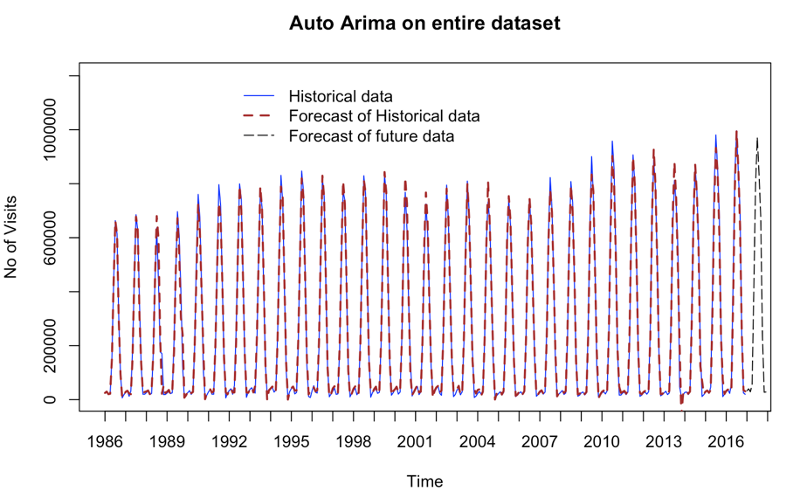

## Model Comparison

This is the most important step in Time Series Forecasting, we need to generate performance measures that evaluate the models we built and find out the most accurate one. Here, we used accuracy() function to evaluate the performance of the models we built on the Yellowstone historical data. We are focusing on the MAPE and RMSE measures of forecasting models for comparison. Where MAPE is percentage score of how forecast deviates from actual values and RMSE is standard deviation of residuals. The MAPE and RMSE values are shown below:

|  |  |  |
| --- | --- | --- |
| **Model** | **MAPE** | **RMSE** |
| Holt Winter’s | 15.469 | 38614.17 |
| Regression Model with Seasonality | 17.23 | 56039.07 |
| Two-level Model  (Regression with Seasonality + Trailing MA for residuals) | 59.928 | 44093.77 |
| Auto ARIMA | 25.146 | 28591.36 |
| Seasonal Naïve | 15.797 | 37542.37 |
| Naïve | 155.282 | 186958.7 |

The above accuracy measures indicate that Holt Winter’s model has substantially better **MAPE(15.469)** and **RMSE(38614.17)** than all other models except for Seasonal Naïve Forecast. While MAPE for Holt-Winter’s is marginally better than Seasonal Naïve (15.797), the RMSE is better than HW at 37542.37. Taking into consideration the superiority of MAPE we conclude that Holt-Winter’s Model is more accurate model and is our final choice of the forecasting model to project number of Visitors in 2017 for Yellowstone National Park.

# Conclusion

In conclusion, time series analysis is very important component for businesses. Every single organization which has to succeed it has to self-analyze and understand itself in terms of performance, achievements, etc. Likewise, Yellowstone should ensure use of time series  method  for forecasting when necessary if it has to give its visitor the best experience of their lifetime. Since 2008, annual visitation to Yellowstone has increased by more than 40%, causing overflowing parking lots, a rise in traffic jams, roadside soil erosion and vegetation trampling, and unsanitary conditions around busy bathrooms. Half of this increase in visitation occurred in just two years (2014 to 2016), coupled by an even greater rise in motor vehicle accidents (+90%), ambulance use (+60%), and search and rescue efforts (+130%). Yellowstone administration can do  proper planning of staff and volunteer if visitor data can be forecasted in the future.

Time Series can be used for forecasting in the future using either data driven approach  or model-based  approach. Forecasting always requires a model, and Holt-Winters is a way to model three aspects of the time series: a typical value (average), a slope (trend) over time, and a cyclical repeating pattern (seasonality). In this scenario the best result is given by the Holt Winter’s Model  a data driven approach ). Holt-Winters forecasting is surprisingly powerful despite its simplicity. It can handle lots of complicated seasonal patterns by simply finding the central value, then adding in the effects of slope and seasonality.

The performance of a Naïve forecasting model should be the baseline for determining whether the values are good. If the model chosen is forecasting worse than a naïve forecast, then clearly the forecasting process needs improvement. If model forecasting results are about the same as a naïve forecast, then why bother? Just use the naïve forecast and save a lot of effort. If the model chosen is doing somewhat better than a naïve then the model forecast can be considered good. In our project, we can see Holt Winter Model gives the least MAPE of 15.469, it means that our forecast has a margin of error of 15.47% which is much better than the baseline Naïve forecast. We also evaluated various model-based methods like Regression model with Seasonality, ARMA and ARIMA models but none of them were as good as Seasonal Naïve Forecast or Holt-Winter’s model. Therefore, we can also conclude that data-driven methods for forecasting Yellowstone National Park is better than model-based methods.

# Limitations & Way Forward

Ideally, visits to National Parks are dependent on a lot of factors like weather, climate, macroeconomic conditions etc. However, we have kept this project consistent with the scope of the course and limited it to the utilization of historical data to forecast the future values. This project can be extended to incorporate other factors as additional variables that can potentially influence our forecast accuracy.

Additionally, it is known that aggregated data and data with slightly higher level of granularity can result into better forecasts. Therefore, as an extension we can roll up the monthly data into quarterly data to build forecasting models and compare the performance measures with our current models.

We also believe that Ensemble techniques or building multi-level models using data-driven methods may result into better forecasts with even lower MAPE and RMSE values for the Yellowstone National Park visitors.

# Appendix

## Bibliography

*TEXTBOOK:*

Shmueli, G. and Lichtendahl Jr., K.C. Practical Time Series Forecasting with R, 2nd Edition, Axelrod Schnall Publishers, 2016. ISBN-13: 978-0-9978479-1-8.

*LECTURE MATERIALS:*

Developed by Dr. Zinovy Radovilsky, Professor of Management, California State University, East Bay

*WEBLINKS:*

<https://www.yellowstonenationalpark.com/>

<https://www.kaggle.com/snehal1405/yellow-stone-national-park>

<https://www.travelwyoming.com/national-parks-and-monuments/yellowstone>

## Forecast Tables

Training Data Set



Validation Data Set :



HW Model Point forecast for Validation Period

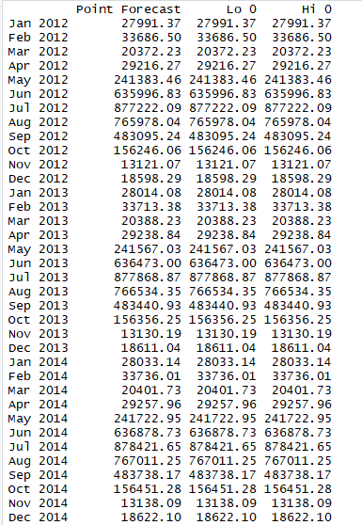 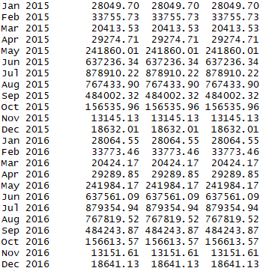

HW Model Point Forecast on Historical Dataset

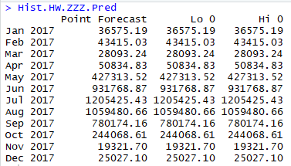

Regression Model with Seasonality for Validation Period

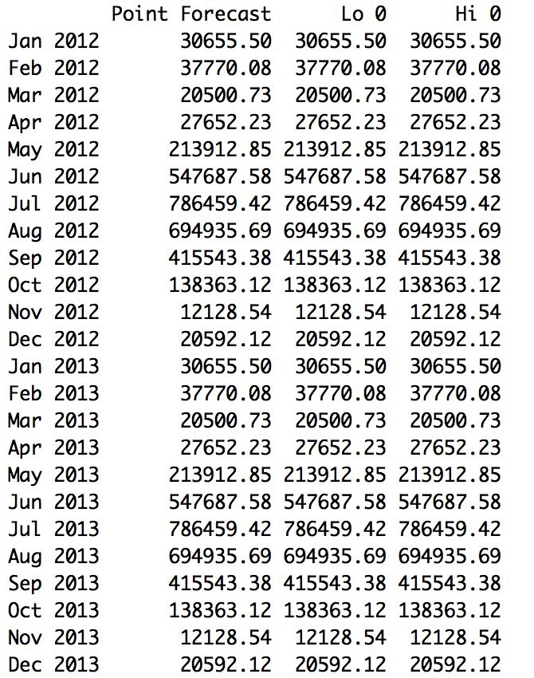

Regression Model with Quadratic Trend and Seasonality for Validation Period

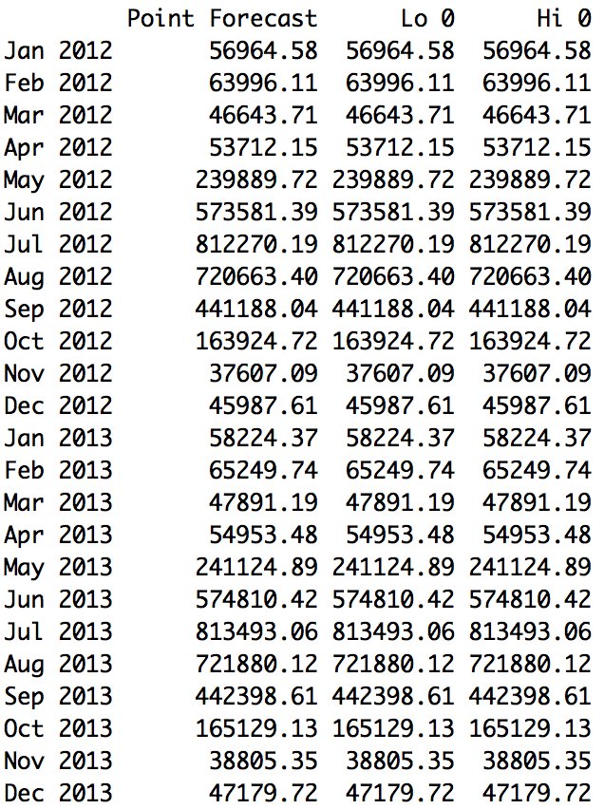

Regression Model with Seasonality in the Future

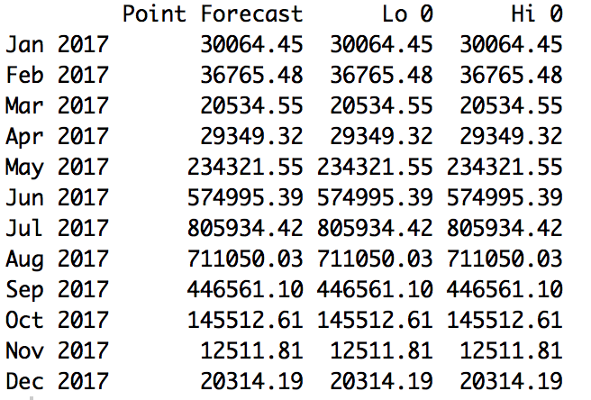

Autoregressive (AR) Model of Order 2 Point Forecast for Validation Period



Moving Average (MA) Model Point Forecast for Validation Period



Autoregressive Moving Average (ARMA) Model Point forecast on Validation Period



ARIMA(2, 1, 2) (1, 1, 2)[12] Model Point Forecast for Validation Period



Auto Arima Model Point forecast on Validation Dataset



Auto Arima Model Point Forecast in the Future

